Practical no.4
Code:
print("___traffice signal ruel___")
signal =input("enter the signal colour(red / yellow / green):")

if signal =="red":
print("action:stop")
elif signal =="yellow":
print("action:wait")
elif signal =="green":
print("action:go")
output: 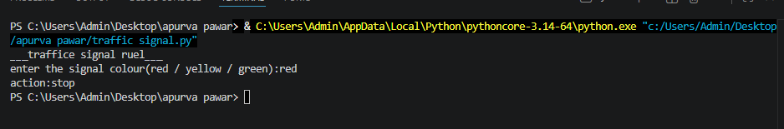

exersice
Q1.Develop an automated order –tracking simulation system that takes a status keyword (eg. “shipped”,delivered”,pending”) and output a customized logistics tracking update message.

Code:
status=input("Enter your order status(shipped/delivered/shiping):").lower()
if status == "shipped":
print("Your orded has been shipped and is on its way...")
elif status == "delivered":
print("Your ordered has been delivered successfully...")
elif status == "pending":
print("Your ordered is pending and will be processed soon...")
else:
print("Invalid status. Please enter shiped , delevered, or Pending")
output: 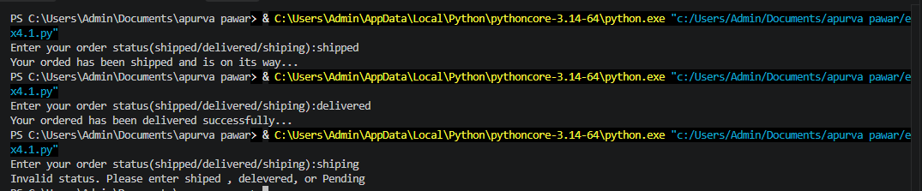

Q 2.Build a basic smart –home climate monitoring script that reads an atmospheric status string and print out hardware recommendations (eg.turn on ac ,activate heater, idle).

Code:
status=input("Enter atmospheric status(hot, cold, normal) :").lower()

if status == "hot":
print("Recommendation : Turn on AC .")
elif status == "cold":
print("Recommendation : Active heater.")
elif status == "normal":
print("Recommendation : Keep the system idle.")
else :
print("Invalid atmosphereic status.")
output: 